Windows 11 Accounts
An Account is required when setting up a new computer running Windows 11. This is done by the Startup Wizard dialog when the computer is turned on.
The Account is usually an existing Microsoft Work/School or Personal Account. You can use an existing Microsoft account or create a new Microsoft account during the Wizard startup dialogue.
You may elect to not use a Microsoft account and instead create a local Account (local to the PC) during the Wizard dialogue. Whichever type you choose, be sure to give the Account Administrative privileges.
Following the Wizard setup, you can create addition Accounts (using Microsoft Accounts) or Users.
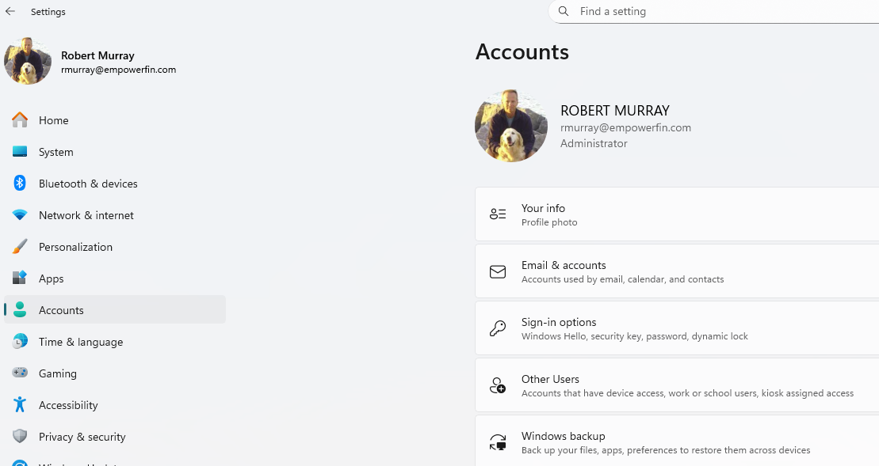

Windows 11 Other Users
To provide access for additional users run the Settings app and click on Other Users in the Navigation panel on the left.
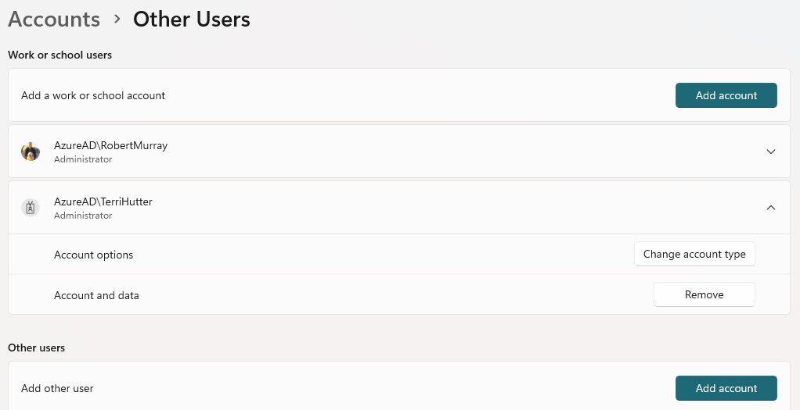
The Add Account button at the top across from Add work or school account enables you to add an Account for the PC using Microsoft Accounts.
The Add Account button in the middle, across from Add other users, enables you to add local Users for the PC.
In either case, the user’s type may be Administrator or Standard User.
.

Windows 11 PRO – Local Users and Groups
With Windows 11 PRO version the Computer Management app provides a UI to manage System Tools, Storage and Services and Applications.
Under Tools, click on Users and Groups to create and edit local users, groups and built-in users and groups.
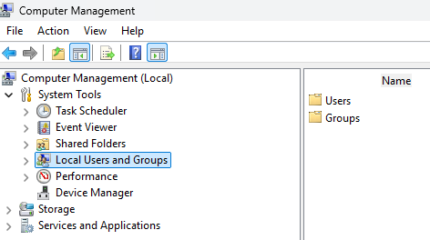
Click on Users
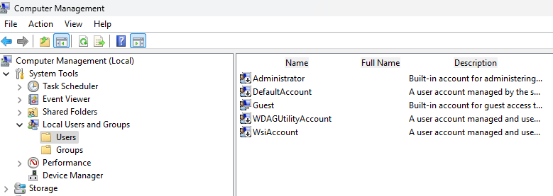
The built-in Administrator account is automatically created when you set the PC.
It is not intended for everyday use as a user. It can be enabled or disabled. It has elevated privileges.
It does not have a password. It is disabled on EFWS08, EFWS07, and EFWS05.

Click on Groups
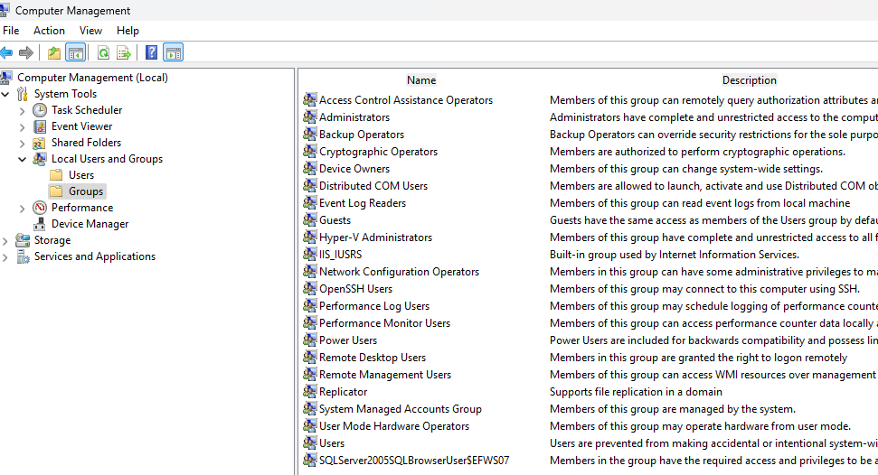

Windows 11 Groups – Empower Users
Run the Settings app, click on Tools, click on Local Users and Groups, right click on Groups, click on New Group.
Add the Empower Users group.
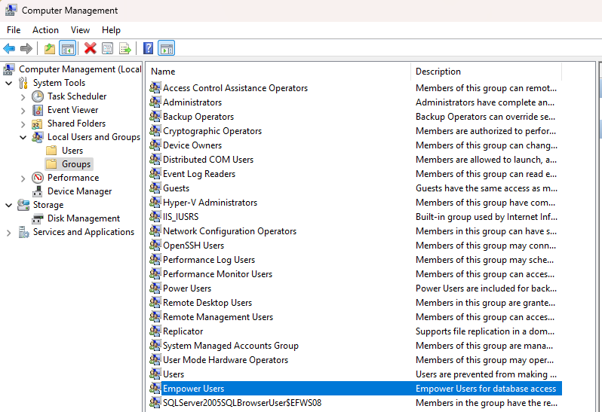

Once the Empower Users group is added, right- click on the group and select properties.
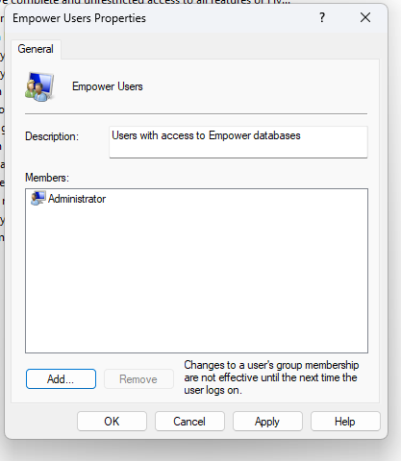
You cannot add the local Account(s) even though they are of Type Administrator. However, you can add the built-in Administrator account. To do so click on the Add button, then type Administrator into the resulting pop-up window, click on Check Names and you will see the account as shown below.
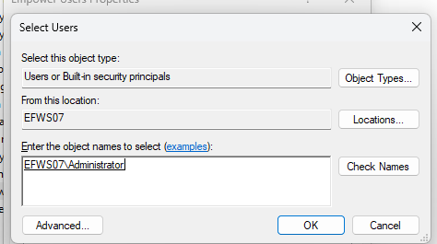
Click OK and the Member Of group box will show Administrator as a member of the Empower Users group.

Windows 11 Accounts and SQL Server Authentication
Using SQL Server Management Studio, you can connect to an instance using SQL Server authentication or Windows Authentication.
For SQL Server authentication the username/password of sa\EFWS07 or sa\EFWS08, respectively, works
Windows authentication works differently.
Then using Computer Management we add all Empower Users to the Empower Users group.
This allows us to connect to SSMS using Windows Authentication.

